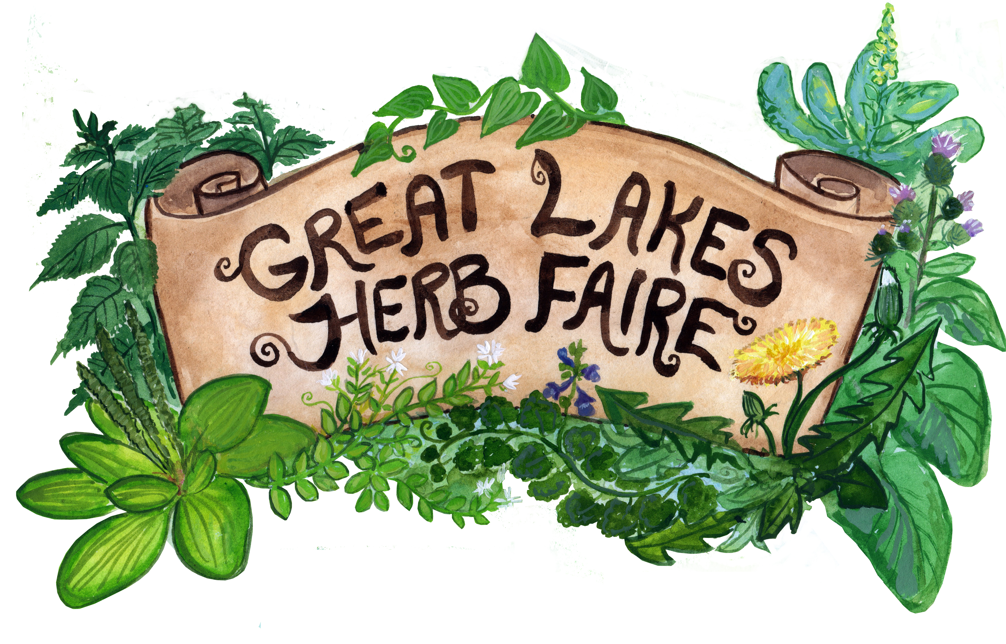
SPONSORSHIP

The 2023 Great Lakes Herb Faire will be a two and a half day in person gathering in Chelsea, Michigan (near Ann Arbor) dedicated to the sharing of herbal knowledge and the celebration of our community and bioregion. We will have dozens of speakers primarily from around the Great Lakes with a seasoning of herbalists from non-Great Lakes states. Our intention is to empower knowledgeable herbalists and beginners alike, provide a space for networking and sharing knowledge and to
strengthen our regional herbal community.

To ensure a successful Faire, we have depended on having amazing sponsors! We would like to
form a symbiotic relationship with you as our sponsor! We help you grow by promoting your business
and you help the faire be successful through sponsorship. There will be between 250 and 300 participants
at the Faire where we thank all our sponsors verbally as well as in our booklet, we have over 4000
herbal enthusiasts following our Facebook page where we introduce and thank all our sponsors and
many more who see our website (potentially with your name, logo and link).

We hope you consider supporting this wonderful herbal educational opportunity that will help
strengthen the health and vitality of our community!

Below you will find the different sponsorship levels and the benefits of each…

$100 Lake St. Clair Sponsor
- Verbal recognition of your company during keynote speaker and closing ceremony.
- Inclusion of your name in our program guide (provided to all attendees)
- Our most heartfelt thanks!!!

$250 Lake Ontario Sponsor
- Verbal recognition of your company during keynote speaker and closing ceremony.
- Business name and link on our website
- Inclusion of your name in our program guide (provided to all attendees)
- Our most heartfelt thanks!!!

$500 Lake Erie Sponsor
- Verbal recognition of your company during keynote speaker and closing ceremony.
- Registration for one
- Business name and link on our website
- Vendor space for the weekend.
- Inclusion of your name in our program guide (provided to all attendees)
- Our most heartfelt thanks!!!

$1000 Lake Michigan Sponsor
- Verbal recognition of your company during keynote speaker and closing ceremony.
- Onsite display of products or brochures throughout the weekend
- Registration for two with lodging and meals
- Vendor space for the weekend
- Medium logo and link on our website
- Placement of name & logo in our program guide (provided to all attendees)
- Our most heartfelt thanks!!!

$1500 Lake Huron Sponsor
- Verbal recognition of your company during keynote speaker and closing ceremony.
- Onsite display of products or brochures throughout the weekend
- Registration for three with lodging and meals
- Vendor space for the weekend
- 30 second ad played during opening ceremony (provided by sponsor).
- Large logo on the back inside of the booklet and link on our website
- Placement of name & logo in our program guide (provided to all attendees)
- Our most heartfelt thanks!!!

$3000 Lake Superior Sponsor
- Verbal recognition of your company during keynote speaker and closing ceremony.
- Onsite display of products or brochures throughout the weekend
- Registration for four with lodging and meals
- Vendor space for the weekend
- 60 second ad played during opening ceremony (provided by sponsor).
- Large logo on the back of the booklet and link on our website
- Placement of name & logo in our program guide (provided to all attendees)
- Our most heartfelt thanks!!!

We deeply appreciate your interest in supporting the Great Lakes Herb Faire; if you have any questions, would like to initiate sponsorship at any of these levels (or in some other way), please either:
- Fill out the attached sponsorship form
- Click on the Sponsorship Form on our website www.greatlakesherbfaire.org
- Email Jackie Delisi at info@greatlakesherbfaire.org,

With green blessings!

The Great Lakes Herb Faire Crew

