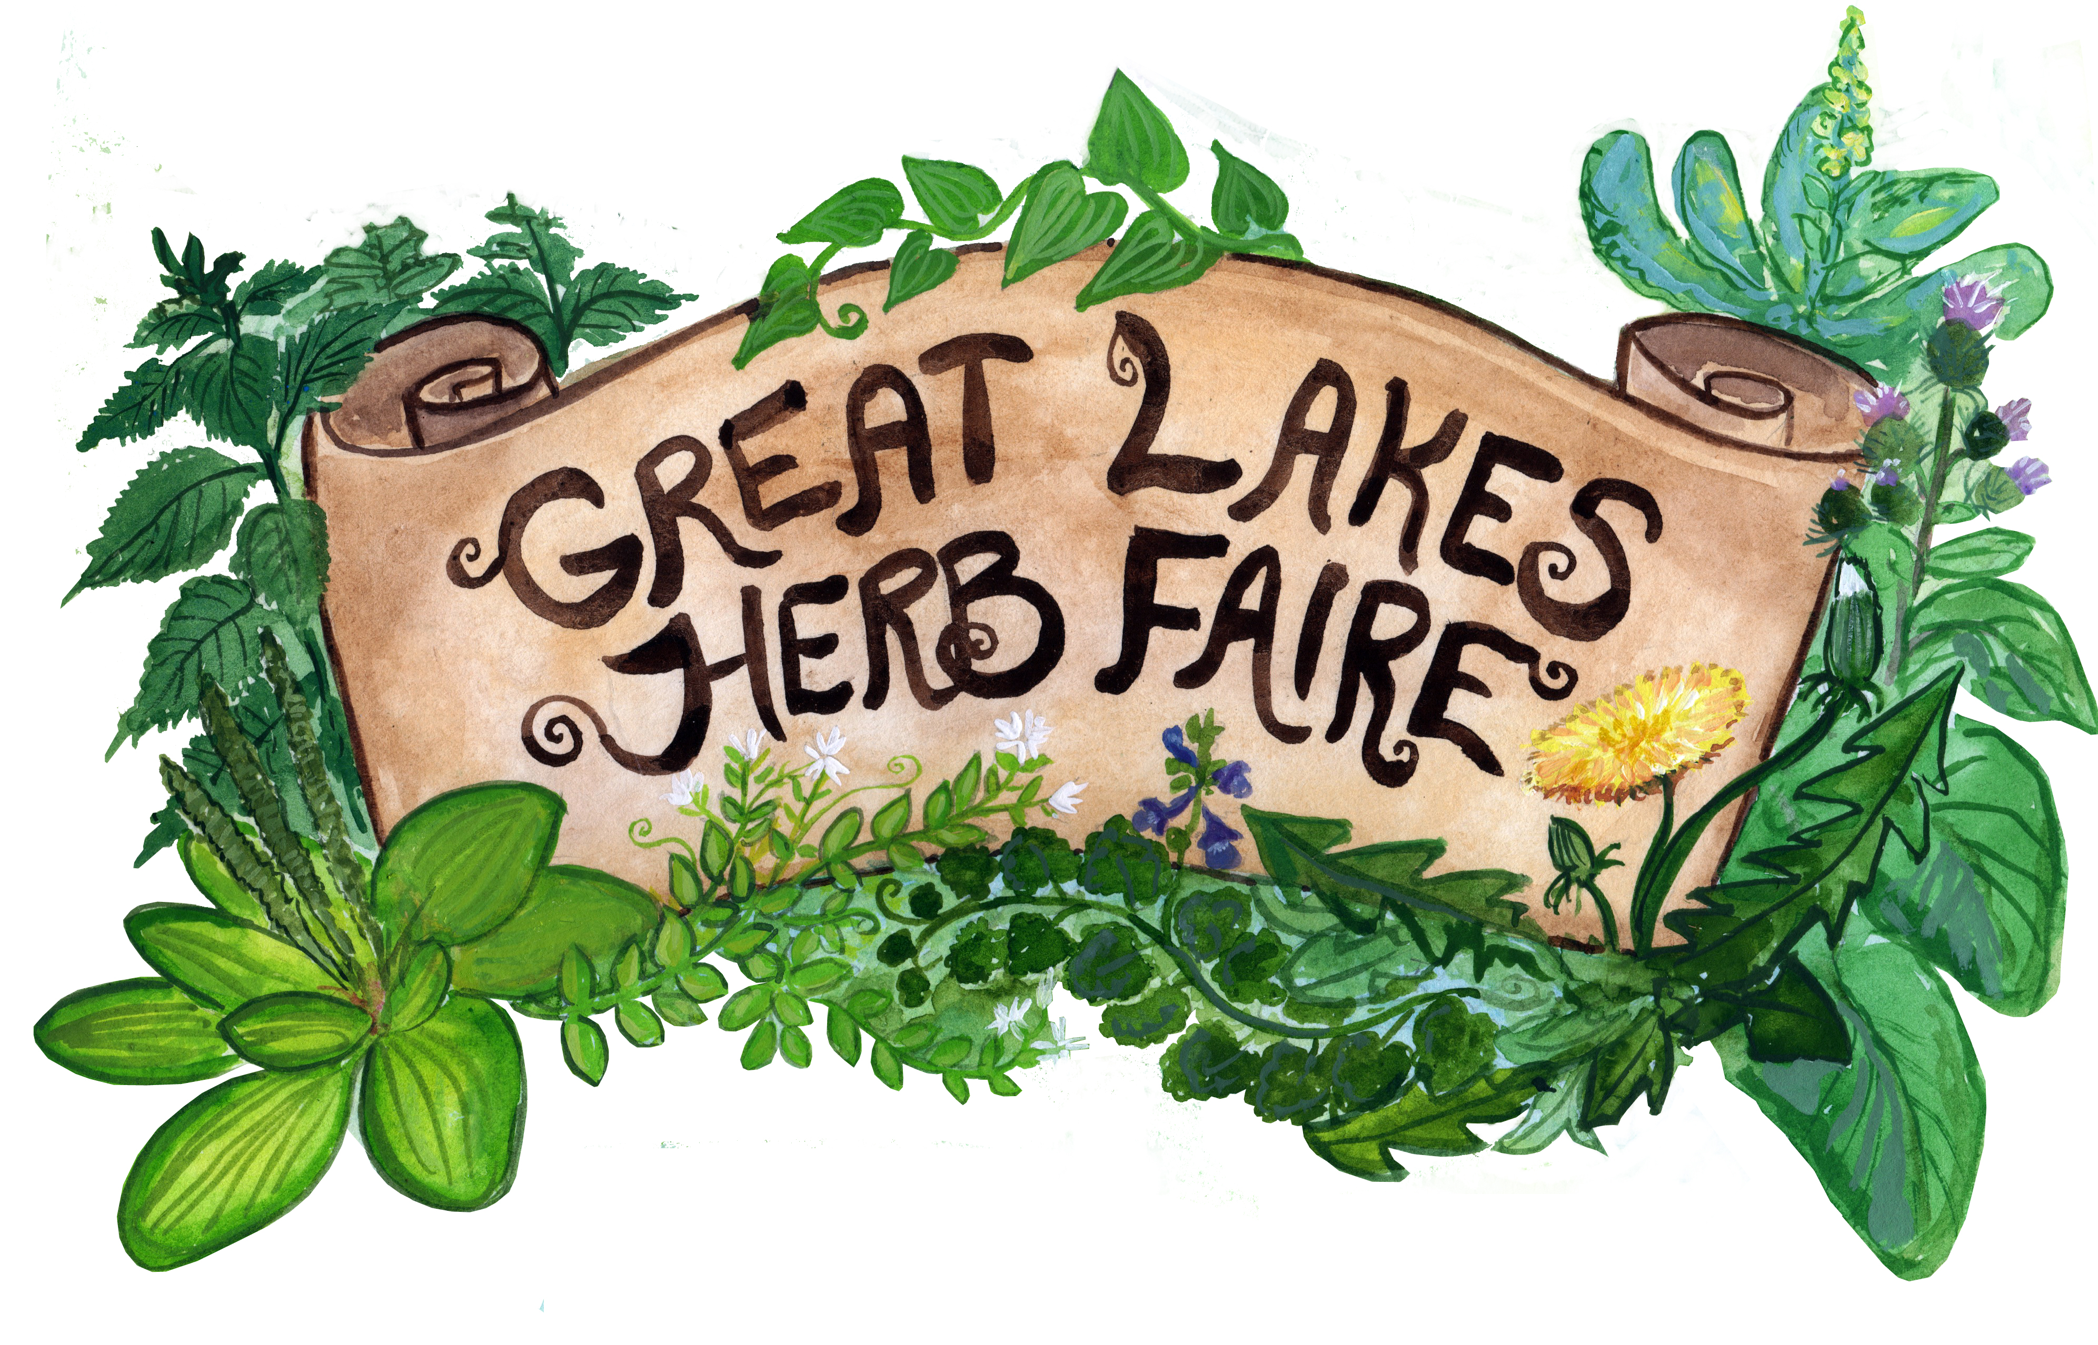
Great Lakes Herb Faire
September 8th – 10th, 2023

Sponsorship Application

Please fill out completely and return with sponsorship funds to address below. Thank you for helping to make the Great Lakes Herb Faire a great success!

- Contact Name

- Business or Organization

- Website

- Address

- email

- Phone

Which level of support would you like to offer, and what exact amount? Please see our Sponsorship Level form for more info on the levels.

Lake St. Clair ($100) ____________
Lake Ontario ($250) ____________
Lake Erie ($500) ________________
Lake Michigan ($1000) _________
Lake Huron ($1500) ____________
Lake Superior ($3000) _________

Please send payments to:
Great Lakes Herb Faire
1841 Alhambra Dr.
Ann Arbor, MI 48103

Or see our website for a paypal link: www.greatlakesherbfaire.org

For more information, please contact Jackie Delisi, Sponsor Coordinator:
Jdelisi2@charter.net

