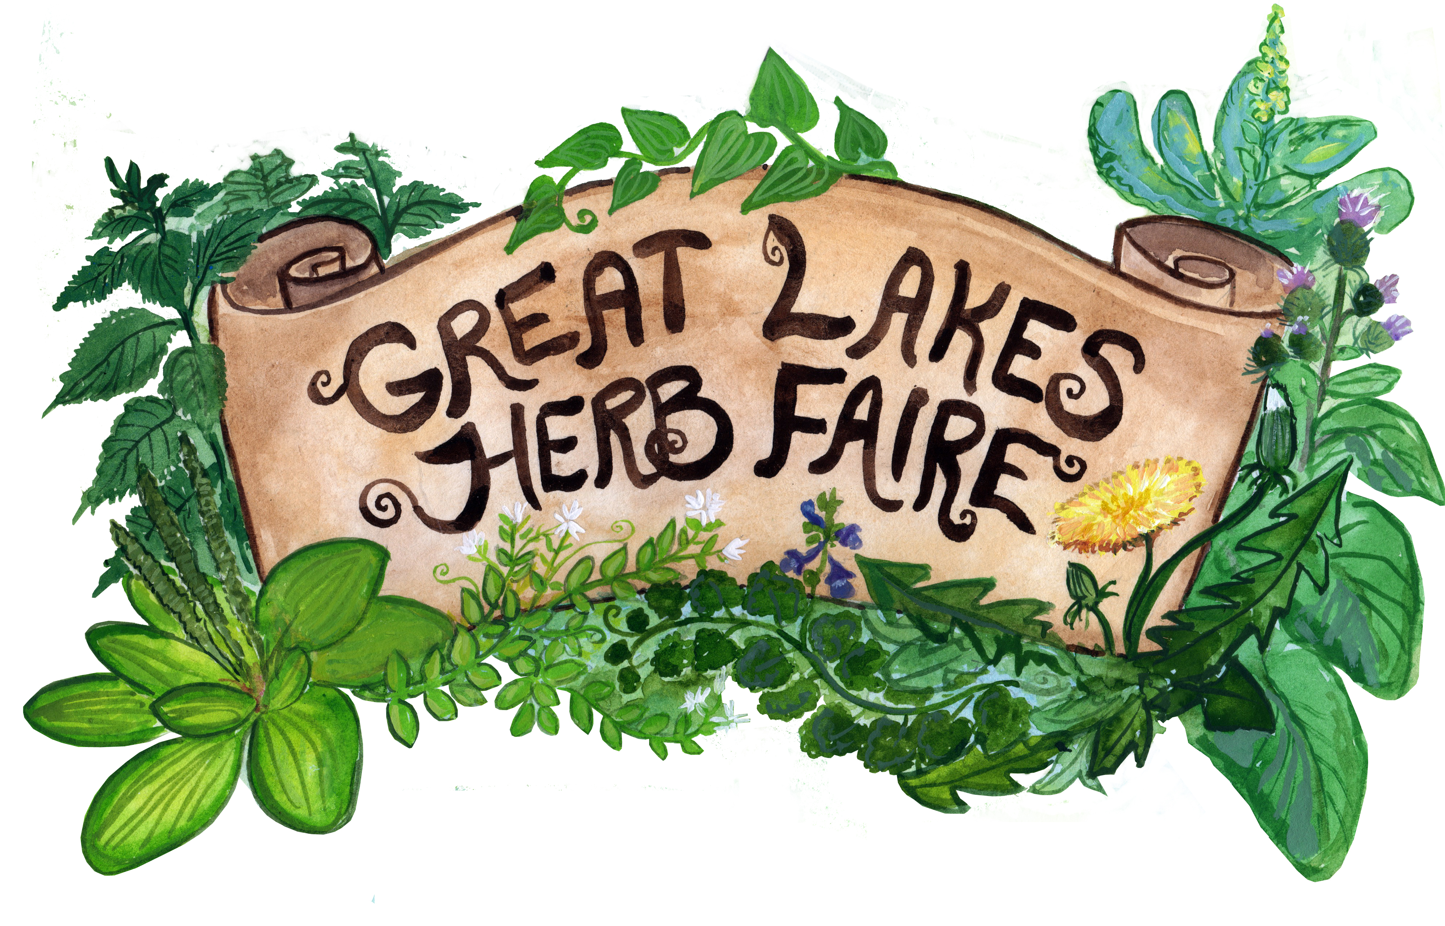
Great Lakes Herb Faire
September 8th-10th, 2017

Sponsorship Application

Please fill out completely and return with sponsorship funds to address below. Thank you for helping to make the Great Lakes Herb Faire a great success!

- Contact Name

- Business or Organization

- Website

- Address

- email

- Phone

Which level of support would you like to offer, and what exact amount? Please see our Sponsorship Level form for more info on the levels.

Lake St. Clair ($100)_____________
Lake Ontario ($250)_____________
Lake Erie ($500) ________________
Lake Michigan ($1000) _________
Lake Huron ($2500) ____________
Lake Superior ($5000)__________

Please send payments to:
Great Lakes Herb Faire
11150 Boyce Rd
Chelsea, MI 48118

For more info:
www.greatlakesherbfaire.org
info@greatlakesherbfaire.org
Anna Fernandez 734-395-5868

