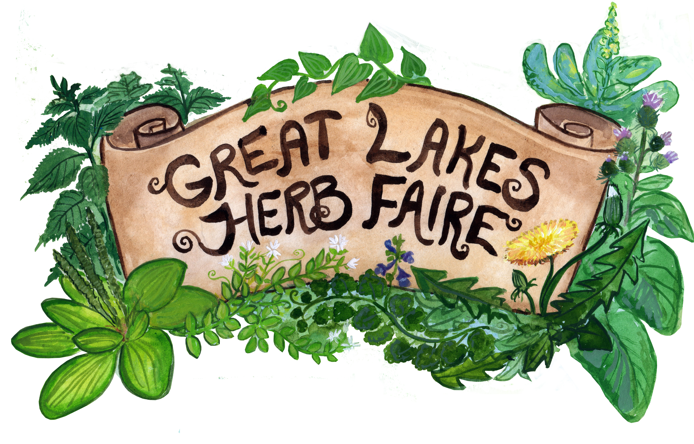
Great Lakes Herb Faire
September 9th – 11th 2022

Sponsorship Application

Please fill out this form completely and return with sponsorship funds to address below. Thank you for helping to make the Great Lakes Herb Faire a great success! Please note: your address, email and phone number will not be shared.

- Contact Name:

- Business or Organization Name:

- Website:

- Address:

- Email:

- Phone:

Which level of support would you like to offer? Please place an “X” next to your chosen level.
See our Sponsorship Level form for more info on the levels.

 | Lake St. Clair | $100
 | Lake Ontario | $250
 | Lake Erie | $500
 | Lake Michigan | $1000

Please send check or money order payments to:
Great Lakes Herb Faire
1841 Alhambra Dr.
Ann Arbor, MI 48103

Or see our website for a Paypal link: www.greatlakesherbfaire.org

For more information, please contact Jackie Delisi, Sponsor Coordinator: Jdelisi2@charter.net

