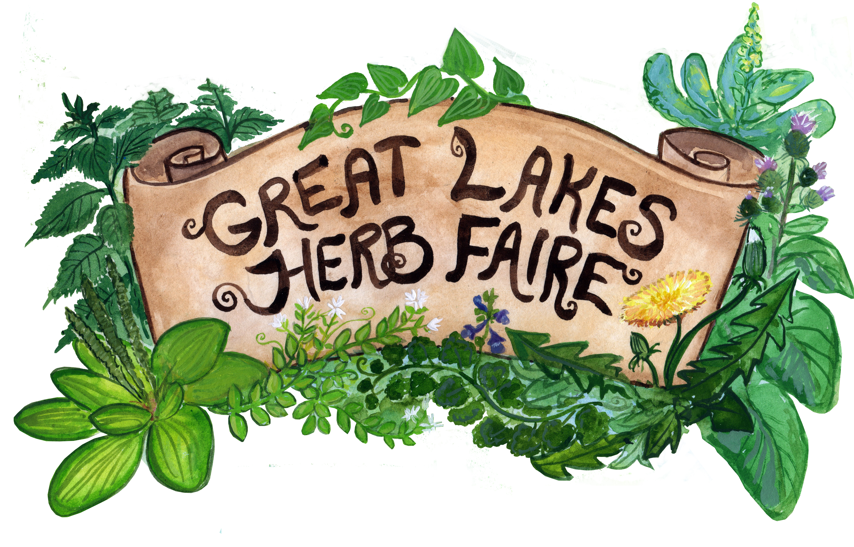
Presenter Application for the
Great Lakes Herb Faire
September 7th-9th, 2018

Thank you for your interest in presenting at our faire!!

We hope you will join us and share your knowledge as we gather for the fourth Great Lakes Herb Faire. The intention of our faire is to help build community among folks interested in herbs, to share and spread the vast wealth of knowledge that our regional herbalists have, and to empower people to become more intimate with not only their own wellness and that of their families and communities, but this amazing land we share.

If you would like to be a part of this sharing of knowledge, and are interested in teaching a class, leading a workshop or field walk, please fill out this application.

Please email to info@greatlakesherbfaire.org or snail mail to
Great Lakes Herb Faire
11150 Boyce Rd
Chelsea, Mi 48118

What we offer to our teachers:

· Tuition/Room & Board: Guest teachers will receive free admission to the faire as well as room and board. Teachers are welcome to camp or stay in a cabin. Cabins are rustic. Some say, very rustic. Requests are welcome if you would like to stay with other teachers in a cabin, co-ed cabin etc.

· Bring a Guest: Teachers may bring one guest who will be admitted to the faire for free as well. Guests will need to pay for their meal plan.

· Vending Space: Educators get first opportunity to have a booth space and need pay no fee in honor of their teachings. All vendors must supply their own tents, tables etc.

· Stipend for Service: At this time we are paying our teachers $100 per class. We hope that the Faire is a great success this year (as it was last year) and if it is, we will pay $50 more per class as we did last year.
·

What we ask of our teachers:

- We are looking for teachers who have a passion for their subject and feel excited to share their knowledge. Ideal teachers would engage their students on different levels, with different modalities, possibly including using lecture, stories, hands on techniques, stimulating the senses, spiritual and theoretical discussion, student led approach etc.
- Each class should be about an hour and a half long. Possibly shorter for kids classes, depending on the age group.

It is very possible that we will have more applications than we have time slots for them to teach. We appreciate all of the applications we get and will thoughtfully look them over before deciding which will fit best in the 2017 Faire. If we are unable at this time to accept your proposal, please take no offense and please do consider applying again for the next faire! We appreciate your understanding.

Name:

Business name if applicable:

Contact Information:

Town and State in which you live:

Phone/Cell number:

Email address:

Website if applicable:

Mailing Address:

Potential Presentation Title: List up to three.

1)

2)

3)

Please give us a paragraph about your potential presentations. Use more space if needed.

1)

2)

3)

What is your experience with teaching this subject?

1)

2)

3)

Do you consider this class for kids, adults, beginners, intermediate/advanced students?

1)

2)

3)

How long would you ideally need for this class?

1)

2)

3)

What kind of set up would you need to teach this class? - ex. for medicine making, you might need a table or electricity.

1)

2)

3)

Which day would be your preference to teach: (circle one)

Saturday, September 8th

Sunday, September 9th

No preference

Please indicate if you would plan to stay over night and would like a bed in one of the cabins or would like to camp. Circle or highlight below:

Not staying overnight

Would like a bed in the teacher's cabin

Would like a bed in the general cabins, with (please list names of attendees):

Would like a camping spot

Will you want a vending space? yes/no

Please include a short bio about yourself along with a picture. Thanks!

Please email application to info@greatlakesherbfaire.org

Feel free to email if you have any questions.

